**Module Code -** KV6011

**Module Name –** Business Intelligence

**Module Tutor –** David Hastings

**Student Number –** W20137581

**Submission Date –** 19/01/2025 (extension accepted)

**Word Count –** 4200

Table of Contents

A. Introduction 3

B. Problem exploration 4

C. System Analysis and Conceptual Modelling 6

1. Big Picture Model 6

2. Activity model - 8

3. Causal loop diagrams - 10

4. Balanced scorecard - 11

5. Strategy maps - 14

D. KPI development 16

E. Dashboard Design Explanation 19

1. Link to Dashboard – 19

2. Purpose of the Dashboard – 19

3. Justification for Design Choices – 19

4. Insights from the Dashboard – 20

F. Decision Making and Conclusion 22

References 25

# Introduction

The report provides a thorough analysis of DLF Ltd., which is one of the largest publicly listed real estate companies in India now, using Business Intelligence (BI) tools and techniques. It aims some key problem areas which is rebuilding customer trust and enhancing transparency, which is crucial for DLF to get a competitive advantage in the market.

The report will explore various models, such as big picture models, activity models, causal loop diagrams, balanced scorecards, strategy maps, etc. and from the insights received, further analysis will be done. The report would uncover elements that influence DLF’s performance and market portfolio by further analysing these models. These models help to identify ineffectiveness, potential areas for improvement and strategies to address challenges.

Big picture model helps us identify the problem from a wider perspective by identifying who benefits, who is impacted, what changes occur and external limitations. Activity models help identify inefficiencies and potential areas for improvement in DLF’s customer interaction and service delivery plans. Causal loop diagrams help provide insights into the possible strategies and objectives to accomplish goals in an achievable manner. Balanced scorecards and strategy maps help identify enhancements to the internal process might lead to better external results.

The report then would be able to derive many Key Performance Indicators (KPIs), which would help understand the challenges within the organisation better and effectively address the issues. These KPIs will serve as critical metrics to measure performance, track progress, and guide strategic decision-making within DLF.

Overall, this report aims to provide actionable insights into the challenges and opportunities within DLF Ltd., facilitating informed decisions that drive organizational effectiveness and market success. By using BI tools and techniques, DLF can enhance effectiveness, rebuild trust and ensure success in a rapidly evolving real estate market.

# Problem exploration

India now has been named the world’s 5th largest economy according to Acharya (2024) and also one of the fastest-growing economies in the world (World Bank, 2024). India has also surpassed China to become the world’s most populated country. As a result, there is a huge rise in the real estate market. The real estate market has been gradually recovering since Covid 19 due to low interest rates, low prices, the need for home ownership and buyers wanting a lifestyle upgrade (Bisaria and Sharma, 2024).

Over the past decade, Indian real estate industry has faced numerous challenges, including incomplete projects, builders embezzling public funds, illegal buildings being demolished, projects being delivered far too late, and many more. Amrapali had cheated 49000 homebuyers and diverted funds of Rs. 5,500 Crores via multiple businesses, bogus bills and many more methods (Roy, 2019). Supertech was ordered to demolish the twin skyscrapers in Sector 93A, Noida, by the Supreme Court of India, which declared the construction to be unlawful. Additionally, the realtor was mandated by the court to pay back the homeowners at a 14% interest rate but hasn’t done so as they have declared bankruptcy. (Ghosh, 2022). Customers often relate these issues with a lack of transparency and accountability, even from reputed developers like DLF.

Because of such incidents, people had lost trust in the government and real estate as it was the authorities who allowed these projects and builders to cheat people in the first place. To address these challenges Real Estate (Regulation and Development) Act of 2016, or RERA, was implemented whose primary goal was to restore the public's and investors' faith in the market. It ensured that the businesses complied with delivery schedules and protected the interests of the customers (Bajaj Finserv, 2024). Due to this, the unsold inventory in Noida and Greater Noida has declined significantly. Noida had 11379 unsold units in 2019 which further reduced to 4745 in 2024, and Greater Noida had 30,924 units in 2019 which further went down to 9953 units (Mishra, 2024). This meant a reduction of 58.3% in Noida and a 67.8% decrease in Greater Noida. Despite these improvements, rebuilding customer’s trust remains a huge challenge, particularly for large developers like DLF, who operate in a highly competitive and scrutinized environment.

DLF’s success in the Delhi NCR region which is the national capital region of India depends upon their ability to restore and sustain their customer’s trust. Due to the upcoming Noida International Airport being made and growing corporate activity, the demand for residential and commercial properties is expected to grow (Zaidi et al., 2024). However, potential buyers now prioritize transparency in pricing, construction progress and compliance with RERA standards. DLF must openly address these expectations which will set them apart from their competitors and attract long-term customer loyalty again.

The mix of these challenges points to a central problem: DLF must transform its customer trust and transparency mechanisms to maintain market leadership in an increasingly regulated and customer-centric environment. Customers now demand clarity in every aspect, like construction timelines, time taken for complaint resolution. By addressing these challenges, DLF can set itself apart from the rest of their competitors and build a long-lasting relationship with their customers.

In conclusion, while RERA has improved the real estate market, DLF still must do regular audits and sustain customer’s trust. Using business intelligence tools to monitor compliance, improve customer’s trust and provide insights will help achieve goals of DLF to strengthen its reputation and secure leadership in the evolving business of real estate.

# System Analysis and Conceptual Modelling

## Big Picture Model

The rich picture provides insights into the challenges and opportunities within DLF’s workings. It highlights the interdependencies between stakeholders, processes and external factors. It shows how all of them are an extremely important part in rebuilding customer’s trust and sustaining market leadership.

By seeing the relationship between key components, the picture identifies areas requiring attention quite well and quickly. For example, delays in resolving customer’s complaints will show less trust and complete compliance enhances customer’s trust and the brand’s reputation as well. The picture also emphasizes role of external factors such as RERA in shaping an organisation.

Overall, the rich picture shows a wider view of DLF’s ecosystem, which shows a deeper understanding of how system improvements can increase efficiency, customer satisfaction and revenue growth. It is the foundation for developing strategies and solutions to work on to address the main problem.

#### CATWOE

**Customers** – Property owners, buyers, tenants, investors.

**Actors** – DLF employees, construction workers, property managers, real estate agents

**Transformation** – converting undeveloped and less populated land and spaces into high-quality real estate projects while maintaining these properties and taking care of sustainability.

**Weltanschauung** – Professional and futuristic real estate development and management increases customer satisfaction and trust through quality infrastructure while taking care of sustainability.

**Owners**- DLF’s board of directors, shareholders, management

**Environment** – Real estate market conditions, RERA regulations, competition, economic factors, development policies, environmental regulations.

#### Root Definition

A system to enhance customer satisfaction and rebuild trust, by means of an efficient complaint handling and resolution process, in order to improve DLF’s brand reputation and customer satisfaction and trust.

#### The 3 E’s

* **E1** – efficacy – How many complaints have been resolved within 48 hours?

**Metrics** – Rate of complaint resolution.

* **E2** - efficiency – How much negative feedback have been received for the complaint’s updates?

**Metrics** – customer satisfaction through surveys

* **E3** - effectiveness – Does resolving complaints improve customer trust and satisfaction?

**Metrics** – Net Promotor Score (NPS)

## Activity model -

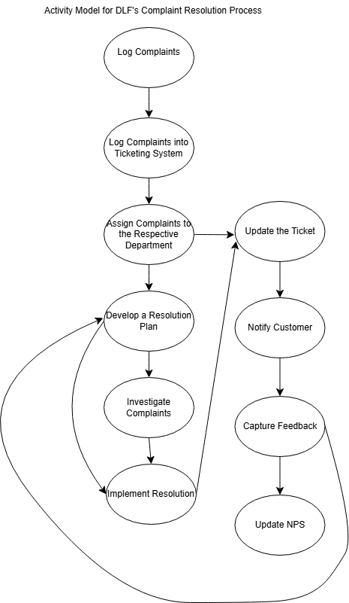

#### Insights from the Activity Model –

The activity model shows us some important steps needed to resolve a complaint efficiently and increase customer satisfaction.

1. It shows a proper logical flow from receiving a complaint which is then logged into a ticketing system to updating NPS. The entire process is well structured which will therefore reduce delays and errors.
2. Transparency is increased by giving ticket updates at multiple stages to customers so that they are informed about the status of their complaint at every stage and would then therefore reduce more complaints about the status of their complaint. It builds trust and transparency in DLF for customers.
3. Assigning complaints to specific departments and letting them work on a resolution helps using skills of every department and resolving complaints easily and quickly.
4. Notifying customers of everything and getting their feedback helps involving customers on every step of the way. It also helps in the learning and growth process.

Understanding customer’s requirements and issues help the company to evolve and address most commonly visible issues. Also utilising an AI based chatbot which easily understands customers complaints and sends them to the specific department and understanding commonly asked questions and answering them online only without the need of a proper complaint.

This activity model lays down a solid foundation for identifying problems within the company and ensures customers’ satisfaction and rebuild customers’ trust.

______________________________________________________________________________

## Causal loop diagrams -

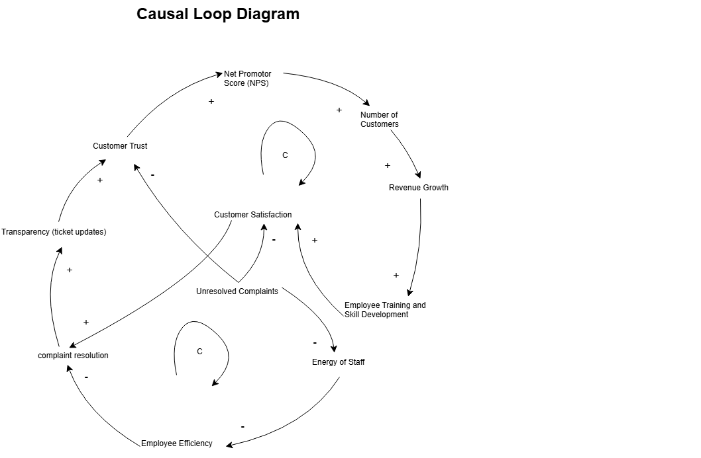

#### Insights from the Causal Loop Diagram –

The causal loop diagram shows how changes in one area affects the overall outcomes.

1. The first loop which is the positive one shows –

On increasing the **rate of customer complaint resolution** → increases **transparency in ticket updates**→ which increases **customer trust** → which helps increase **NPS**→ increases **number of customers** → increased **revenue growth** → increased **employee training and skill development** → increased **customer satisfaction**.

This, in turn, attracts more customers increasing revenue growth in the end.

1. The second loop which is the negative one shows –

More **Unresolved complaints** → Low **Energy of Employees** → decreases **employee efficiency** → reduces **complaint resolution rate** → more **unresolved complaints.**

If workload is increased too much then, employee’s fatigue leads to slower or ineffective complaint resolutions. This reduces customer satisfaction, highlighting the need for better employee training and skill development by resource allocation.

Training employees to increase their skills is a critical point. Addressing this through more training will increase the employees’ efficiency and reduce fatigue because it helps them manage their workload and would turn the negative loop to positive.

There is also a direct connection between customer trust and increase in revenue growth which means increasing the rate of customers’ complaints resolution would yield more customer trust and increase transparency.

Also addressing customer’s feedback would help identify key areas of concern and improvement and increase customer satisfaction.

By addressing these issues, DLF can increase customer satisfaction and revenue growth by focusing on sustaining the positive loop.

## Balanced scorecard -

|  |  |  |  |  |
| --- | --- | --- | --- | --- |
| ***Vision and Strategy*** | ***Objective*** | ***Measure*** | ***Target*** | ***Initiative*** |
| **Financial Perspective** | **Increase revenue growth** | Revenue growth rate | 20% growth annually | * Launch premium projects near Noida Intl. Airport * Target corporate clients for office spaces. |
| **Improve compliance** | Compliance score | 75% compliance within the next 18 months | * Conduct audits quarterly. |
| **Improve project delivery** | Project completion time | 90% of projects are delivered within the scheduled time | * Implement new Project Management software |
| **Reduce net debt** | Net Debt-to-GAV ratio | Reduce to 60% by 2027 | * Clear unsold inventory |
| **Increase market share** | Revenue share in NCR market | 15% increase by 2027 | * Build corporate partnerships. * Diversify offerings with affordable housing with luxury segments. |
| **Clear unsold inventory** | Percentage of unsold units sold | 50% reduction by 2027 | * Focus marketing efforts on existing inventory. * Offer competitive pricing and financing options. |
| **Customer Perspective** | **Improve Customer Trust** | Net Promoter Score | Achieve an 65 trust rating by 2026 | * Implement transparent pricing. * Implement a Progress Reporting system. * Launch CRM tools for real-time updates |
| **Improving after-sales customer relationship** | Customer satisfaction through surveys | 90% satisfaction by 2027 | * Establish a dedicated post-sales support team. |
| |  | | --- | | **Increase visibility through digital marketing** |  |  | | --- | |  | | Increase in social media growth | 45% increase in social media engagement annually. | * Launch **video campaigns** with testimonials. * Live Q&A sessions * Virtual Site tours on YouTube and Instagram. |
| **Improve complaint resolution rates** | Complaint resolution time | Resolve 90% of complaints within 48 hours | * Launch a centralized complaint resolution ticketing system. * train staff to resolve disputes effectively. |
| **Expand digital services** | Online inquiry-to-sale conversion rate | 20% increase annually | * offer AI-based customer personalization. |
| **Promote eco-friendly projects** | Percentage of green project sales | 50% increase in eco-friendly property sales by 2028 | * Highlight green features in marketing campaigns. * Educate customers about sustainability benefits. |
| **Internal Business Processes** | **Increase brand reputation** | RERA Compliance score | 80% compliance within the next 18 months | * Conduct quarterly audits. |
| **Reduce waste** | Construction waste | 30% reduction | * Implement recycling. * Usage of green materials. |
| **Develop sustainable practices** | Percentage of green-certified projects | 50% by FY27 | * Partner with green consultants * Integrate energy-efficient designs into projects. |
| **Strengthen quality control** | Quality compliance score | 95% adherence to standards | * Ensure all projects align with RERA regulations. |
| **Enhance rental income** | Rental income growth | 20% annual increase | * Focus on leasing unsold commercial spaces. * Offer long-term contracts with corporate tenants. |
| **Learning / Growth** | **Develop Employee Skills** | Employee skill certification rate | 100% relevant certification completion | * Launch comprehensive training programs |
| **Advanced innovation and collaboration** | The number of ideas implemented. | 1 idea researched and implemented quarterly | * Internal challenges to get ideas. * Rewarding employees for their input. |
| **Support employee wellness** | Participation in wellness programs | 80% participation by 2027 | * Offer fitness programs, mental health support, and flexible work arrangements. |
| **Improve digital skills** | Percentage of employees trained in digital tools | 2 training programmes quarterly completed 100% | * Train employees on CRM, project dashboards, and AI-powered solutions. |
| **Promote diversity and inclusion** | Diversity index | 30% female workforce by 2027 | * Ensure inclusive hiring practices. * Establish mentorship programs for underrepresented groups. |
| **Improve employee satisfaction** | Satisfaction survey score | 90% by 2026 | * Offer competitive benefits. * Recognize high performers. * Promote flexible work arrangements. |
|  | **Flexible work arrangements** | Percentage of employees with flexible working time schedule | 50% by 2026 | * Offer employees to work from home. * Employee people to work part-time. |

#### Insights from the balanced scorecard -

The balanced scorecard provides insights which aligns DLF’s objectives related to financial, customer perspective, internal business processes and learning and growth. By checking objectives, measurable KPIs, targets and initiatives, it makes the objectives and KPIs clearer.

1. **Financial Perspective –**

This perspective shows how shareholder expectations, focusing on growth, increased sales, and productivity matter. It highlights critical areas of revenue growth, compliance, project delivery times, debt reduction, market share and reduction of unsold inventory. The metrics show that sustainable growth leads to financial stability.

1. **Customer Perspective –**

It identifies how customers perceive value and emphasize on improving customer relations through good customer service. It also focuses on improving customer’s trust through surveys, digital reach, complaint resolution and green projects. Improving transparency and reducing the time for complaint resolution boosts the customer’s satisfaction and enhances engagement.

1. **Internal Business Processes –**

These focus on operational of the business. Objectives like reducing waste, developing sustainable practices, and strengthening quality control directly increases brand reputation and investment opportunities for more investors. It makes sure that all the projects built meet environmental standards.

1. **Learning / Growth –**

It focuses that the employee’s skills are improved. Initiatives like increasing employee training, diversity and wellness programs increase innovation and collaboration which directly focuses on productivity and brand reputation and customer’s satisfaction. If the employees are trained well, then they make sure that the customer’s complaints are resolved quickly.

## Strategy maps -

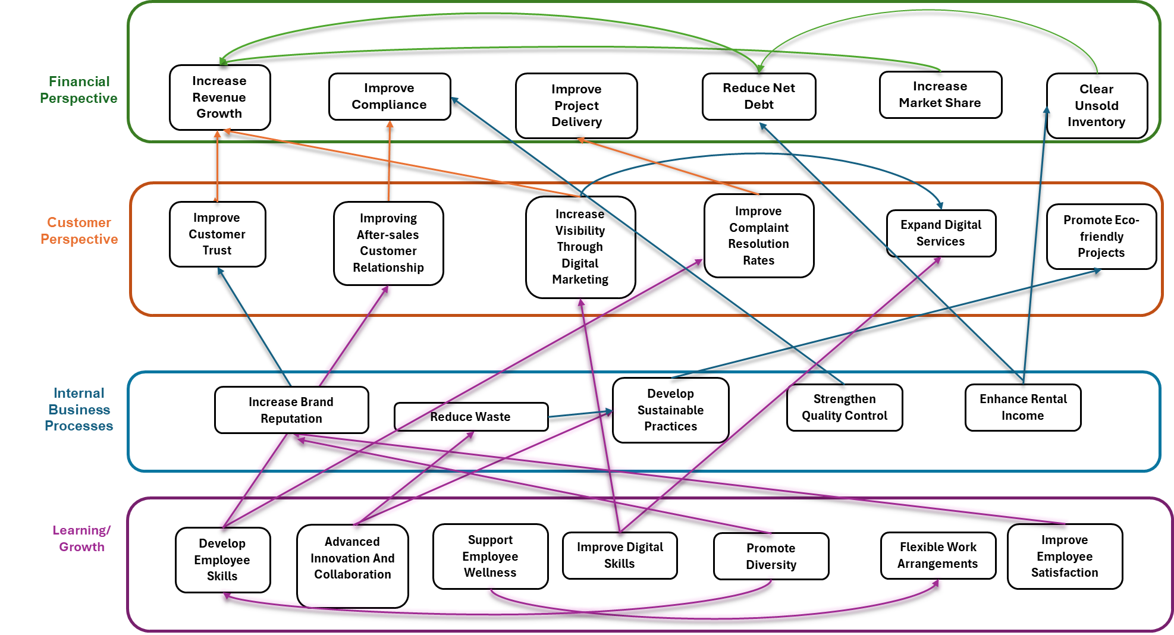

#### Insights from the Scorecard –

The strategy map connects the balanced scorecard as a representation showing the interdependencies between all the objectives. It highlights how everything is interrelated, and the end goal is increase in revenue growth.

1. **Financial Perspective –**

Increasing revenue growth ensures higher profitability and long-term stability. Expanding the product range allows DLF to attract a diverse customer base and tap into emerging markets. Decreasing net debt leads to improved revenue growth, enabling further investments in innovation and sustainability. Enhanced rental income reduces the unsold inventory and therefore more revenue which reduces the net debt. Also increasing compliance is extremely important which is clearly visible through the map.

1. **Customer Perspective –**

Customer’s trust is improved through improved compliance with RERA regulations and requirements. Improving complaint resolution rates also help in improving project delivery. It helps reducing costs. If the project is completed on time, the construction costs are also less. Digital tools for customer engagement also help leading to increase in customer satisfaction and trust. It helps directly to boost sales.

1. **Internal Business Processes –**

Sustainable practices, such as achieving LEED certifications, improve brand reputation and attract economically conscious customers. Increasing brand reputation automatically increases after-sales customer relationships because customers start trusting the business. Promotion of eco-friendly projects help attracting more investors. Reducing waste and sustainable practices also helps in reducing costs. It also makes sure DLF is able to deliver high-quality projects.

1. **Learning and Growth –**

Training employees is a crucial step in satisfying customer needs. Improving their digital skills directly helps in increasing visibility through digital marketing and expanding their digital services, which increases revenue growth. supporting wellness of employees by flexible work arrangements also help develop employee skills. Increasing employee skills also lead to advanced innovation and collaboration which leads to increased sustainability and increases customer experiences which leads to increased revenue through customer’s trust being increased.

# KPI development

**From the strategy maps these were the most strategic objectives -**

1. Increase revenue growth.
2. Improve compliance.
3. Reduce net debt.
4. Improve customer trust.
5. Develop employee skills.
6. Develop sustainable practices.
7. Promote Diversity.

**KPIs from the objectives -**

1. Quarter over Quarter Revenue Growth
2. Complaints and Grievances resolved annually.
3. Net Debt quarterly
4. Debt-GAV ratio quarterly
5. NPS Score of Residential customers annually.
6. Number of properties achieving LEED Zero Water and Waste certification annually
7. Percentage of employees completing required training annually
8. Percentage of women over total employees annually

**Justifications for the KPIs –**

1. **Quarter over Quarter Revenue Growth–**

For real estate developers like DLF, revenue growth is the main driver of market performance and business expansion. This KPI is directly related to the company’s ability to build residential and commercial spaces and generate sustainable income streams. People have started moving to luxury spaces more now as the economy of India improves. The analysis of DLF’s performance in the past 5 years show that revenue growth shows great sales performance and long-term market position.

For DLF, tracking revenue growth across all the sectors would provide great insights in the portfolio performance.

The revenue growth is an important KPI because it is the end goal for all the other indicators.

1. **Complaints and Grievances resolved annually–**

After the proper implementation of RERA in the Indian real estate, compliance is a key indicator in the performance of major businesses. Compliance with RERA also results in no project delays and costs also reduce because there is no overrun of costs. Strengthening quality control and developing employee skills would automatically results in an improved compliance. This KPI was selected because it directly impacts more and easy project approvals, building a huge customer loyalty and support. For DLF, maintaining high compliance standards is extremely important for maintaining the stakeholder’s trust and operational productivity. A strong brand enables premium pricing, faster project launches, and easier to launch into new markets. This KPI was selected because RERA compliance and market reputation depends on it. Increasing brand reputation also means more clientele and increase in customer’s trust which automatically results in increased revenue growth.

1. **Net Debt quarterly–**

Real Estate development requires a highly significant amount of capital investment, making debt management extremely crucial. This KPI was chosen because it reflects DLF’s financial health. Lower debt levels mean reduced interest rates, better credit ratings and the investors would also have more trust.

Reduction of debt directly improves the revenue growth.

1. **Debt-to-GAV ratio quarterly–**

GAV includes operational portfolio, under construction projects and potential revenue from newly developed projects. Having a lower ratio helps improve credit and investor’s confidence. For DLF, a low ration ensure better interest rates and marks the company as a reputed company in front of investors who will invest in new projects.

1. **NPS Score of Residential customers annually –**

In real estate, customer’s trust is extremely important. This KPI was chosen because it directly depends on improving the revenue. It improves the brand reputation as well and increases customer referrals. High trust levels lead to faster sales and reduces the marketing costs as well. It is extremely important for DLF to improve their customer’s trust for sustaining market leadership.

1. **Number of properties achieving LEED Zero Water and Waste certification annually–**

Sustainability has been a concern in the real estate industry because of developments and operations. The whole world is moving towards a cleaner and a greener Earth initiative, having DLF as a leader in these fields would enhance market positioning and also invite more investors. There is also a strong demand for environmentally responsible construction solutions. Sustainable practices also lower operating costs. It also appeals to environmentally conscious customers and

investors.

1. **Percentage of employees completing required training annually –**

Training employees is extremely important to meet the extremely strong demands of Indian real estate. Training makes sure employees complete full compliance and digital skills as well. Increasing training courses makes sure DLF helps its workplace is able to be extremely skilled in CRM systems and project dashboards. Skilled employees also will be able to maintain a ticketing system of customer service complaints. For DLF, training employees automatically means increased operations and better customer satisfaction rates.

1. **Percentage of women in managerial positions –**

Diversity is extremely important in businesses, because it has high benefits in the real estate sector. Research shows that after an increase in diversity in the workplace, the revenue had seen a 35% increase (Hunt, Layton and Prince, 2015). It also demonstrates innovation capabilities. For DLF, promoting diversity would help in increasing the brand reputation which will attract investors who value inclusivity and will therefore increase their revenue.

# Dashboard Design Explanation

### Link to Dashboard –

<https://livenorthumbriaac-my.sharepoint.com/:u:/g/personal/w21037581_northumbria_ac_uk/EfQgiCMhKJFNueqSxoMnwCoB30BpPc4wabRyRAIpLZ7r9w?e=FfTa70>

### Purpose of the Dashboard –

The dashboard helps us identify the key performance indicators for DLF and focus them particularly on all perspectives – financial perspective, customer perspective, internal business processes and learning and growth. It has a lot of interactive features like slicers, drill throughs and visuals as a guidance for decision making process. It has some uses like how regional managers can use the NPS map to allocate resources to underperforming regions.

### Justification for Design Choices –

#### Visualisations Used –

1. **Cards** – This is used to display single values. It is easy to see and identify the metrics without complex visuals and data.
2. **Line Chart** – It is used to visualize trends over time such as financial year, quarterly. It is ideal for seeing patterns and comparison during a long-term performance and help make easily informed decisions.
3. **Map** – It is used to visualize regional data like NPS. Using heatmaps in it, it is easily identifiable which regions have a higher score.
4. **Line and Clustered Column Chart** – This is used to compare 2 metrics like in the financial perspective page we compare revenue vs operating costs quarterly. It helps us analyze the relation between them to identify profits easily.
5. **Pie Chart** – It is used to show parts of a whole like it is used to compare the percentage of female in the workplace. It is quite easily visible to see the proportions as well.
6. **Gauge** – it helps for quick evaluation and understand at a glance.
7. **Bar Chart** – it helps compare data like increase of energy saving percentages annually. It is the most basic graph with all the information.
8. **Clustered Bar Chart** – It helps to compare multiple categories of data side by side like female and male in workplace annually.

#### Interactivity Features Used –

1. **Slicers** – It is used to filter the data Yearly and quarterly dynamically. It helps user focus on specific time instead of checking each graph.
2. **Tooltips** – It provides additional context when hovered over visuals like over graphs with multiple chart types to get the exact data at a point because it is not possible to display all the values on the charts to make it look visually appealing.

#### Overall Layout –

1. **Colour Scheme** – This colour scheme is chosen to enhance readability and usability. Green helps to indicate increase or positive trends like revenue and red helps to indicate debt.

A black background helps minimize pressure on eyes during prolonged use and enhances the contrast colours used which improves accessibility.

### Insights from the Dashboard –

1. **Financial Perspective** - The profit margin calculated when looking through the **revenue vs operating costs** comparison helps to identify quarters that went well for the company and then enable DLF to see what went well and replicate those practices again.
2. **Customer Perspective** – Regional NPS map helps identify the areas where the customer surveys rate is low which helps identify the need to increase more targeted initiatives and need to target that are to improve. Also looking at what is going on well in the high performing areas also helps improve the low performing areas.
3. **Internal Business Processes** – Looking at **complaint resolution rates** helps identify the key problematic areas where the customers are having complaints in and why the complaints are not being resolved on time.

**Sustainability insights** also indicate that how well the company is progressing towards increasing their sustainability goals and hence improving environmental compliance which strengthens DLF’s reputation towards customers as well as investors.

Looking at how well DLF complies with **RERA regulations** also helps move towards a greater customer trust and loyalty base.

1. **Learning and Growth** – Employee turnover rate vs employee satisfaction scores help identify what went wrong in terms of engagement and what areas require improvement.

Diversity metrics help identify inclusivity in the organisation. Increasing diversity also means attracting more people to come and work for the company when they see a diverse working environment which enhances innovation.

# Decision Making and Conclusion

The dashboard is an important tool for using a data driven decision making (DDDM) framework. It helps DLF to understand its potential and improve their operation to improve customer trust, transparency and overall performance.

**Reasons for adopting DDDM** -

1. Adopting DDDM would help DLF predict market’s demand quicker which would reduce unsold inventory by analysing historical sales and demand patterns and customers’ surveys.
2. It would also allow a better resource allocation for projects, like quicker complaint resolution by directing the report to the allocated department which would reduce redundancies and also help with targeted marketing for engaging more customers.
3. Also, a real time analysis of rate of complaint resolution quarterly automatically builds trust and loyalty.
4. Analytics on energy savings and waste recycling and having more projects LEED certified helps build environmentally responsible practices and would attract more investors.

**Requirements for DDDM adoption** –

1. Get data from sales, complaints and sustainability and arrange it properly for unified access.
2. Training employees on digital tools like CRM tools, Business Intelligence tools to interpret data and understand the insights from the same and make everyone else understand it and learn how to act on it.
3. Introduction of a team which validates and implements all data-driven decisions and makes presentations so everyone who is not well-versed in that area is able to understand better.

**Data relevant for DDDM** –

1. Checking for constant customer feedback through updates on NPS scores, complaint resolution rates and customer surveys.
2. Financial data which is revenue, operating costs and debt-to-GAV ratio.
3. Sustainability metrics like LEED certifications, energy saving and waste recycling.
4. Checking employee metrics, which is basically training completion rates, employee satisfaction scores.

All the data insights should be communicated to all the stakeholders so that they are all on the same page. Using dashboards for real time tracking and reports to summarize trends and presentations to explain more in depth about the insights and the improvements needed.

After DLF follows the DDDM framework, it would base the decisions on facts rather than intuition. For example, using AI in BI insights would help predict customer complaints and reduce redundant complaints.

DDDM would have a lot of outcomes like increase in complaint resolution, improved inventory management, and compliance scores.

**Challenges in Adopting DDDM** –

1. Employees and manager are quite well accustomed to traditional methods for decision making and might resist adopting DDDM frameworks. DLF must focus on regular training sessions and also involving employees in the decision-making process rather than just managers.
2. Inaccurate or incomplete information and data can cause problems in decision-making processes. DLF should have proper practices which ensures data collection, storage and processing of accurate and reliable data.
3. Handling sensitive data of both customers and employees by complying with Digital Personal Data Protection Act (DPDPA) standards is the responsibility of DLF.
4. Reducing bias in predictive models and transparency in data usage is essential.

**Benefits of DDDM** –

1. **For customers** – Improvement in complaint resolution rates help enhance transparency within operations of DLF to build trust and a bigger customer base. Customers feel valued and heard when their issues are resolved promptly, and they are a part of the resolution process.
2. **For employees** – Identifying employee performance metrics such as satisfaction and training rates, helps make policies to improve morale and reduce retention. Employees who are better equipped with technology and training feel less fatigued and more confident in themselves.
3. **For investors** – Focussing on sustainability, like increasing LEED certified projects and increasing energy savings would attract more environmentally conscious investors which would boost DLF’s reputation.
4. **For management and board of directors** – Real time dashboards and reports would allow leaders to make quick decisions, anticipate risks and capture opportunities as quickly as possible.

**Impact of DDDM** –

1. DLF can become a leader in sustainable real estate.
2. Customer’s loyalty and trust would be improved highly by better project management.
3. Reduction of delays in project delivery would help DLF to reduce costs and improve profit margins.

Overall, by adopting DDDM, LDF will achieve improved customer trust and loyalty through transparency and efficiency in their operations. There will be improvement in revenue growth using better resource allocation and cost management. DLF would also be able to strongly be compliant with sustainability and RERA standards which increases their reputation. Employees who have been trained with digital tools help drive innovation.

This approach ensures that DLF aligns its strategic goals with effective performance, paving the way for sustainable growth and long-term success.

# References

1. Acharya, M. (2024) *World GDP ranking 2025 list*, *cleartax*. Available at: <https://cleartax.in/s/world-gdp-ranking-list> (Accessed: 25 December 2025).
2. Bisaria, S. and Sharma, S.(2024), Evaluation of Dimensions Impacting the Housing Property Retail Price in Noida: An Empirical Study, *International Journal For Research in Applied Science and Engineering Technology,* 12(V), <https://doi.org/10.22214/ijraset.2024.59776>.
3. World Bank (2024) *India: Overview*. Available at: <https://www.worldbank.org/en/country/india/overview> (Accessed: 5 January 2025).
4. Bajaj Finserv (2024). *RERA Noida*. [online] www.bajajfinserv.in. Available at: <https://www.bajajfinserv.in/know-about-rera-noida> [Accessed 2 Dec. 2024].
5. Zaidi, A., Seth, C., Choudhury, M. and Ranjan, S. (2024). *Real Estate @2047 Road Map for Viksit Bharat 2047*. [online] *Credai*. Available at: <https://admin.credai.org/public/upload/491fd45b96b28f1dbe82efda84095959.pdf> [Accessed 7 Jan. 2025].
6. Mishra, A. (2024). *Noida Real Estate market: Property Prices More than Double in Last Five Years*. [online] Moneycontrol. Available at: <https://www.moneycontrol.com/news/business/real-estate/noida-real-estate-market-property-prices-more-than-double-in-last-five-years-12859262.html> [Accessed 7 Jan. 2025].
7. Roy, D. (2019). *How Amrapali cheated 49,000 homebuyers, according to Supreme Court*. [online] ThePrint. Available at: <https://theprint.in/india/how-amrapali-cheated-49000-homebuyers-according-to-supreme-court/267018/> .
8. Ghosh, S. (2022). *Explained: Why are Noida Twin Towers being demolished*. [online] mint. Available at: <https://www.livemint.com/news/india/explained-why-are-noida-twin-towers-being-demolished-11661442579350.html> [Accessed 7 Jan. 2025].
9. Hunt, V., Layton, D. and Prince, S., 2015. Diversity matters. *McKinsey & Company*, *1*(1), pp.15-29.